**JAVA WEEK 1 DAY 1**

**WHAT IS JAVA**

According to Wikipedia Java is a **general-purpose programming language** that **is class-based, object-oriented,** and designed to have as few implementation **dependencies** as possible. It is intended to let application developers write once, run anywhere (WORA), meaning that compiled Java code can run on all platforms that support Java without the need for recompilation.

**JAVA COMPONENTS**

n this unit you will learn the main components of java. What really makes up java technology.

Let’s familiarize ourselves with the components. The diagram below shows how java code is compiled and executed on a computer.

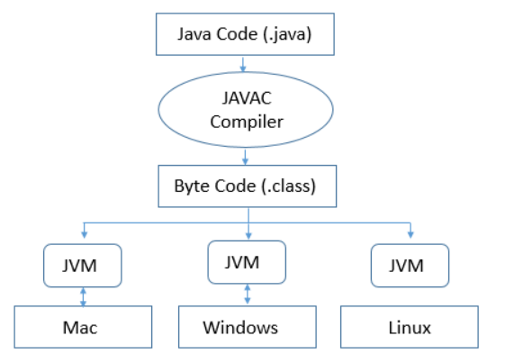

Now let’s take a closer look on the diagram.

* **Java Code(.java)** – this is the java code you have written, and its saved in the .java file(s)
* **Javac compiler** – it compiles the java source code files (.java file) into bytecode so that it can be executed by JVM. The bytecode is saved in a class file by compiler.
* **Bytecode** - this is what is produced by the javac complier after compiling java code.

**Java Virtual Machine (JVM)**

Generally referred as **JVM**, it’s the primary function is to **execute** the **bytecode** produced by compiler.

Each operating system has different **JVM**, however the output they produce after execution of bytecode is same across all operating systems – hence Java is referred regarded as platform independent.

Program execution phases follows this general sequence **write the program**, then **compile the program** and **run the program.**

1) Writing of the program is of course done by the java programmer like you and me.

2) Compilation of program is done by javac compiler, javac is the primary java compiler included in java development kit (JDK). It takes java program as input and generates java bytecode as output.

3) In third phase, JVM executes the bytecode generated by compiler. This is called program run phase.

**Java Development Kit (JDK)**

This is a complete java development kit that includes JRE (Java Runtime Environment), compilers and various tools like JavaDoc, Java debugger etc.

You would need JDK installed on your computer in order create, compile and run Java program(s)

**Java Runtime Environment (JRE)**

JRE allows you to run java programs, it includes JVM, browser plugins and applets support. When you only need to run a java program on your computer, you would only need JRE.

**Note:** It is important to note JRE only runs a compiled java program.

You cannot compile java programs with JRE you will need JDK.

**TYPICAL STRUCTURE OF A JAVA PROGRAM**

**Typical Structure of a Java program**

A typical structure of a Java program contains the following elements:

* Package declaration
* Import statements
* Comments
* Class definition
* Attributes
* Methods/Behaviours

**Package declaration**

A class in Java can be placed in different directories/packages based on the module they are used. For all the classes that belong to a single parent source directory, a path from source directory is considered as package declaration. Keyword **package** is used on package declaration statement

**Import statements**

There can be classes written in other folders/packages of our working java project and also there are many classes written by individuals, companies, etc which can be useful in our program. To use them in a class, we need to import the class that we intend to use. Many classes can be imported in a single program and hence multiple import statements can be written. Keyword import is used on **import** statement

**Comments**

The comments in Java can be used to provide information about the variable, method, class or any other statement. There are two ways to write comments in Java:

* Single line comment - used to comment single line of code. It uses double forward slash (//)
  + - * e.g. // this is a single line comment
* Multiline comment -used to comment multiple lines of code
  + - * e.g. /*This is multiline

               comment */

**Class Definition**

A name should be given to a class in a java file. This name is used while creating an object of a class, in other classes/programs. Keyword**class** is used on Class Definition

**Main Method**

Execution of a Java application starts from the main method. In other words, it’s an entry point for the class or program that starts in Java Run-time.

**Methods/Behaviours**

A set of instructions which form a purposeful functionality that can be required to run multiple times during the execution of a program. To not repeat the same set of instructions when the same functionality is required, the instructions are enclosed in a method. A method’s behaviour can be exploited by passing variable values to a method.